Blocking Cortex AI Functions in Snowflake: USE AI FUNCTIONS Troubleshooting
Nov 9, 2026 · @Chantal

Summary
You can block Cortex AI Functions in Snowsight. A plain REVOKE ... FROM ROLE PUBLIC is not always enough to do it.
The ticket: USE AI FUNCTIONS was revoked from PUBLIC and not granted to any role. An analyst could still run AI_SENTIMENT from a Snowsight worksheet.
What we found:
- The documented exception for native applications does not cover Snowsight. It applies only to queries that run inside a Snowflake Native App.
- The privilege can still reach every user through the SNOWFLAKE.PUBLIC application role, which is granted to account-level PUBLIC. A standard REVOKE does not remove it from there; a dedicated stored procedure does.
- SNOWFLAKE.APP_PUBLIC also holds the privilege and shows up in SHOW GRANTS ON ACCOUNT. That is expected. It applies only to native apps, and customers cannot revoke it.
- The privilege can also arrive through inherited roles, secondary roles or per-function grants. To find the real route, use the queries below together with the role on the analyst's query.

How access is gated
A query from a worksheet must pass two independent gates. Closing either one blocks the call.
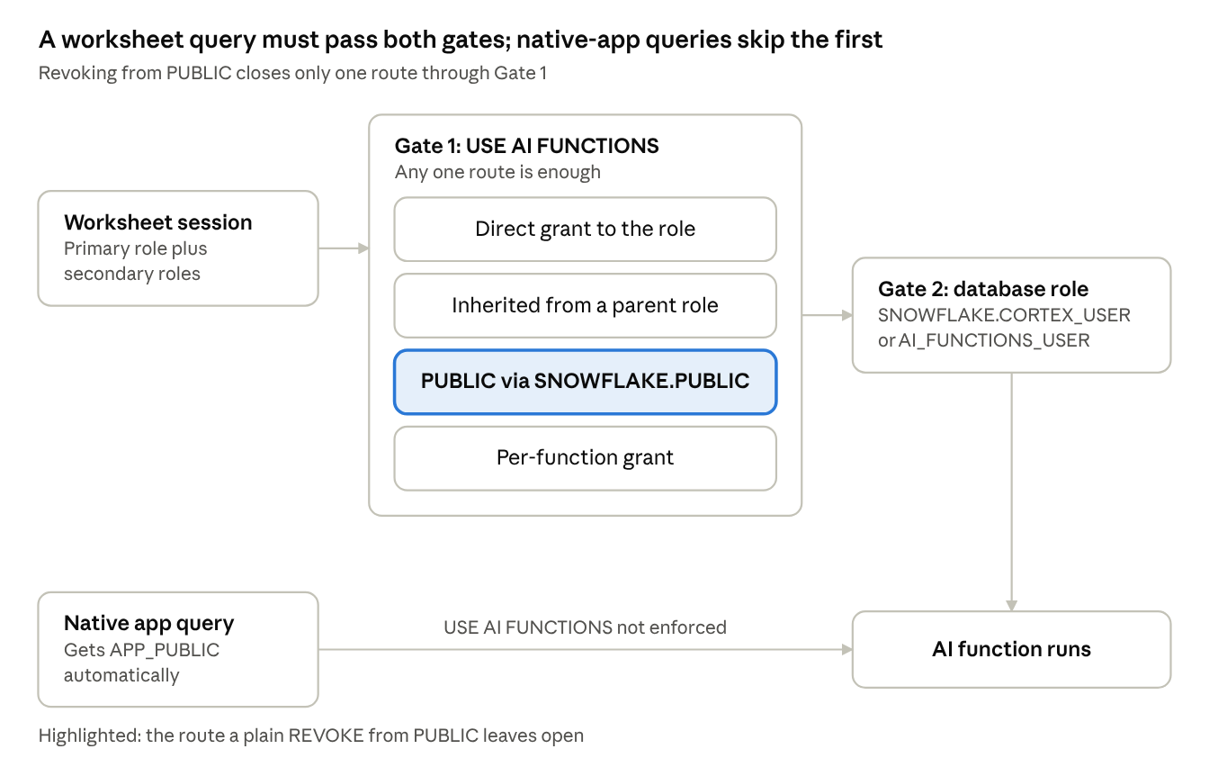
routes to Cortex AI Functions · 2 gates
- Gate 1, the account privilege: USE AI FUNCTIONS, or a per-function USE AI FUNCTION <name> (GA May 2026). It is granted to PUBLIC by default. Revoking a per-function privilege has no effect while the role still holds the blanket privilege, so revoke the blanket privilege first.
- Gate 2, the database role: SNOWFLAKE.CORTEX_USER or SNOWFLAKE.AI_FUNCTIONS_USER. CORTEX_USER is granted to PUBLIC by default; AI_FUNCTIONS_USER is not.
- Native apps: USE AI FUNCTIONS is not currently enforced inside a native application, and apps get their AI capabilities through SNOWFLAKE.APP_PUBLIC.

The native application caveat
The caveat applies only to Snowflake Native Apps. It does not affect Snowsight worksheets.
The documentation says USE AI FUNCTIONS does not apply to AI Function queries that run inside Snowflake native applications. Such queries succeed whether or not the role has the privilege.
A native app is an application installed in the account, for example from the Marketplace or from a provider. Its queries run under the app's own context. A query an analyst types in a worksheet is not a native-app query, so it is still subject to the privilege check.
Practical meaning: if AI functions work in a worksheet after the revoke, the user's session still holds the privilege by some route. Find that route; the native-app exception is not it.

SNOWFLAKE.PUBLIC vs SNOWFLAKE.APP_PUBLIC
Two Snowflake-managed application roles can hold USE AI FUNCTIONS. Only one of them affects Snowsight users, and only that one can be revoked.
Application role | Who it affects | Revocable? | What to do
SNOWFLAKE.PUBLIC | Every user. It is granted to the account-level PUBLIC role. | Yes, but only with the stored procedure below. A plain REVOKE does not remove it. | Check it, then revoke with the procedure.
SNOWFLAKE.APP_PUBLIC | Native applications only. It is activated automatically whenever an app runs (BCR-2437, from Oct 5, 2026). | No. Consumers cannot revoke it or what is granted through it. | Treat it as expected. If an app should not have AI access, uninstall the app.
Check what SNOWFLAKE.PUBLIC currently carries:
USE ROLE ACCOUNTADMIN;
SHOW GRANTS TO APPLICATION ROLE SNOWFLAKE.PUBLIC;
Revoke it the supported way (requires the SNOWFLAKE.SNOWFLAKE_PUBLIC_GRANT_ADMIN application role, which only ACCOUNTADMIN has by default):
CALL SNOWFLAKE.LOCAL.REVOKE_FROM_PUBLIC_APPLICATION_ROLE('PRIVILEGE', 'USE_AI_FUNCTIONS');
- The revocation persists across Snowflake upgrades. A plain REVOKE statement does not.
- Users who received the privilege only through SNOWFLAKE.PUBLIC lose it. Grant it directly to the roles that still need it before you run the procedure.
- To undo the revocation, use SNOWFLAKE.LOCAL.GRANT_TO_PUBLIC_APPLICATION_ROLE.

Diagnostic queries
To find everyone who can call AI functions, run these four checks in order. They cover direct grants, inherited grants, the application roles, and the role the offending query actually ran under.

1. Roles that hold the privilege directly (real time)
SHOW GRANTS ON ACCOUNT;
SELECT "privilege", "granted_to", "grantee_name", "granted_by", "created_on"
FROM TABLE(RESULT_SCAN(LAST_QUERY_ID()))
WHERE "privilege" ILIKE 'USE AI FUNCTION%'; -- also catches per-function grants

2. Every role that inherits it, and the users who hold those roles
This uses ACCOUNT_USAGE, which can lag by up to about 2 hours.
WITH RECURSIVE
direct AS (
SELECT DISTINCT grantee_name AS role_name,
privilege,
grantee_name AS source_role,
0 AS depth
FROM snowflake.account_usage.grants_to_roles
WHERE granted_on = 'ACCOUNT'
AND privilege ILIKE 'USE AI FUNCTION%'
AND deleted_on IS NULL
),
inherited AS (
SELECT role_name, privilege, source_role, depth FROM direct
UNION ALL
SELECT g.grantee_name, i.privilege, i.source_role, i.depth + 1
FROM inherited i
JOIN snowflake.account_usage.grants_to_roles g
ON g.name = i.role_name
AND g.granted_on = 'ROLE'
AND g.privilege = 'USAGE'
AND g.granted_to = 'ROLE'
AND g.deleted_on IS NULL
WHERE i.depth < 20
)
SELECT DISTINCT
i.role_name,
i.privilege,
i.source_role AS inherited_from,
i.depth AS hops,
u.grantee_name AS user_name
FROM inherited i
LEFT JOIN snowflake.account_usage.grants_to_users u
ON u.role = i.role_name
AND u.deleted_on IS NULL
ORDER BY i.role_name, user_name;
Reading the results:
- hops = 0 means the role holds the privilege directly. Higher numbers mean it is inherited.
- If the privilege reaches PUBLIC, every user has it, even though GRANTS_TO_USERS lists no users for PUBLIC.
- Per-function grants (USE AI FUNCTION AI_SENTIMENT, etc.) grant access on their own, without the blanket privilege.

3. Routes the query cannot see
SHOW GRANTS TO APPLICATION ROLE SNOWFLAKE.PUBLIC; -- reaches every user via PUBLIC
SHOW GRANTS TO ROLE PUBLIC;

4. The role behind the ticket's query
SELECT query_id, user_name, role_name, secondary_role_stats, start_time, query_text
FROM snowflake.account_usage.query_history
WHERE query_text ILIKE '%AI_SENTIMENT%'
AND start_time > DATEADD(day, -14, CURRENT_TIMESTAMP())
ORDER BY start_time DESC;
If secondary_role_stats shows the user had secondary roles active (DEFAULT_SECONDARY_ROLES = ('ALL')), the privilege may have come from one of those roles rather than from the primary role.

Remediation checklist
Work through these in order. Steps 1–2 keep approved users working; steps 3–5 close the gaps.
- ☐ Decide which roles legitimately need AI functions (blanket or per-function).
- ☐ Grant USE AI FUNCTIONS (or USE AI FUNCTION <name>) directly to those roles.
- ☐ Revoke from the application role: CALL SNOWFLAKE.LOCAL.REVOKE_FROM_PUBLIC_APPLICATION_ROLE('PRIVILEGE', 'USE_AI_FUNCTIONS');
- ☐ Confirm REVOKE USE AI FUNCTIONS ON ACCOUNT FROM ROLE PUBLIC; is in place, then rerun the diagnostic queries to check that no other role holds it unexpectedly.
- ☐ As a second gate, revoke the database role from PUBLIC: REVOKE DATABASE ROLE SNOWFLAKE.CORTEX_USER FROM ROLE PUBLIC;. Grant CORTEX_USER or AI_FUNCTIONS_USER only to approved roles.
- ☐ Retest as the analyst's role in a Snowsight worksheet: SELECT AI_SENTIMENT('test'); should fail.
- ☐ List installed native apps and record that their AI access through APP_PUBLIC cannot be revoked. Uninstall any app that should not have it.

Sources
- Privileges and model access for Cortex AI Functions
- Snowflake Cortex AI Functions (native application caveat)
- SNOWFLAKE.LOCAL.REVOKE_FROM_PUBLIC_APPLICATION_ROLE
- SNOWFLAKE.LOCAL.GRANT_TO_PUBLIC_APPLICATION_ROLE
- SNOWFLAKE.PUBLIC and SNOWFLAKE.APP_PUBLIC application roles
- BCR-2437: Bootstrap core Snowflake capabilities to native applications
- May 13, 2026: Per-function privileges for Cortex AI Functions (GA)
- Apr 2, 2026: AI_FUNCTIONS_USER database role (GA)

